Integration Test Plan

For

FrugalPhone

Submitted by

Blue Team

Instructor | Gregory Hislop, Jeff Salvage
Team Members | Patrick Freestone, Stephen Prazenica, Johnathan Saunders, Kyle Usbeck, Kimmie Yuan
Date Submitted | 03/02/2007

Table of Contents

1 Introduction 3
1.1 Purpose 3
1.2 Scope 3
1.3 Definitions, Acronyms, and Abbreviations 3
1.3.1 System Components 3
1.3.2 Data Entities 3
1.3.3 Technical Terms 4
1.4 References 5
1.5 Overview 5
2 Component Architecture Description 6
2.1 Mobile Device 7
2.2 Mobile Device Interface 7
2.3 FrugalPhone Server Database 7
2.4 Product Pricing Data Retailer Interface 7
2.5 Admin Console 7
3 Integration Tests 8
3.1 Mobile Device – Mobile Device Interface 8
3.1.1 Successful Comm Message 8
3.2 Mobile Device Interface – FrugalPhone Server Database 8
3.2.1 Invalid Product Input Data Result 8
3.2.2 Zero-Result Database Query 9
3.2.3 Single-Result Database Query 9
3.2.4 Multiple-Result Database Query 9
3.3 Product Pricing Data Retailer Interface – FrugalPhone Server Database 10
3.3.1 Unsuccessful Product Pricing Data Upload 10
3.3.2 Product Pricing Data Location Addition 10
3.3.3 Product Pricing Data Addition 11
3.3.4 Duplicate Product Pricing Data 11
3.3.5 Modified Product Pricing Data Entry 12
3.4 Admin Console – FrugalPhone Server Database 12
3.4.1 Login Success 12
3.4.2 Incorrect Login Failure 13
3.4.3 Add System Administrator 13
3.4.4 Remove System Administrator 14
3.4.5 Change System Administrator Password 15
3.4.6 Change Connection Timeout 16
3.4.7 Add Feed File Location 16
3.4.8 Remove Feed File Location 17
3.4.9 Change Feed File Refresh Rate 17

Introduction

Purpose
The purpose of the integration test plan is to describe the necessary tests to verify that all of the components of FrugalPhone are properly assembled. Integration testing ensures that the unit-tested modules interact correctly.

Scope
FrugalPhone allows consumers to use a Mobile Device to check competitors’ prices for a specific product. Consumers send product information to this service with their Mobile Device. FrugalPhone then returns a list of product pricing results that includes information such as the store name, physical location, price, and the last time the price was validated. GPS-enabled phones also display the distance to the store.

The FrugalPhone service provides several input methods. One format in which a consumer is able to enter product information is a UPC Code. Another format that a consumer could use is product name. A third format is bar code scanning via the camera on camera phones.

The FrugalPhone service gathers pricing data in two ways. One way in which the system gathers pricing data is by browsing web pages. A second way is by allowing retailers to provide product pricing data feeds to the FrugalPhone system.
The objective of this application is to create a more portable version of Internet price-checking websites. Given this objective, the ideal goal of FrugalPhone is to provide the ability to compare product prices anytime and anywhere.

Definitions, Acronyms, and Abbreviations

This section provides definitions for common terms used throughout the document. They are provided to help minimize ambiguity throughout the document.

System Components
- Mobile Device– The application that allows the consumer to enter product input data into the system and view the pricing result data.
- FrugalPhone Server – This is the part of the system that is responsible for gathering the product pricing data from the Internet, as well as communicating with the Mobile Device.
- Admin Console – The interface to the system that allows the system administrator to manage the FrugalPhone server.

Data Entities
- Product Input Data – This is the data about a specific product that the consumer inputs into the Mobile Device that is used to identify the product.
- Pricing Result Data - This is the data returned to the consumer that includes information about the product, locations where it is sold, the prices at those locations, and the distance to the store (GPS-enabled devices only).
- Product Pricing Data – This is the data gathered from the retailers about prices and locations for consumer products. It is used to generate the pricing result data.
- FrugalPhone Server Management Parameters - This is the data that regulates the FrugalPhone server and is controlled by the system administrator.
- FrugalPhone Server Status Updates – This is the data about the status of the FrugalPhone server communicated to the system administrator via the Admin Console.

Technical Terms
  - JSP - JavaServer Pages (JSP) technology provides a simplified, fast way to create dynamic web content. JSP technology enables rapid development of web-based applications that are server and platform independent.

  - Servlets - Java Servlet technology provides Web developers with a simple, consistent mechanism for extending the functionality of a Web server and for accessing existing business systems.

  - JavaBeans - Components (JavaBeans) are reusable software programs that you can develop and assemble easily to create sophisticated applications.

  - CommSystem - Component of FrugalPhone that transfers messages between a Comm Package (Mobile Device) and Comm Package (FrugalPhone Server).

  - HTTP - Hypertext Transfer Protocol (HTTP) is a request/response protocol between clients and servers.

  - JVM - A Java Virtual Machine (JVM) is the program that executes the machine language generated by Java language compilers.

  - XML – Extensible Markup Language (XML) is a general purpose markup language that is used to structure data.

  - Feed – A feed is a data file that is updated at a regular interval.

  - URL – A uniform resource locator (URL) is a unique address for locating a file.

References

The following references are supplemental to the material found in this document:

GS1. GS1 ID Keys – Technical. Retrieved October 15, 2006 from http://www.gs1.org/productssolutions/idkeys/technical/#gtin

Freestone, Prazenica, Saunders, Usbeck, Yaun. Cycle-3 Software Requirements Specification for FrugalPhone. 2007.

Freestone, Prazenica, Saunders, Usbeck, Yaun. Cycle-3 Software Design Specification for FrugalPhone. 2007.

Overview

The table below describes the organization of content across the sections in this document.
Section | Description
1 - Introduction | Define the purpose, scope, and overview of this document.
2 - Component Architecture Description | Describe each of the components of Frugalphone.
3 - Integration Tests | Detail each test necessary to ensure proper integration of each FrugalPhone component.

Component Architecture Description

The FrugalPhone system can be divided into several components. Listed below are the five components and a brief description of each component’s purpose.
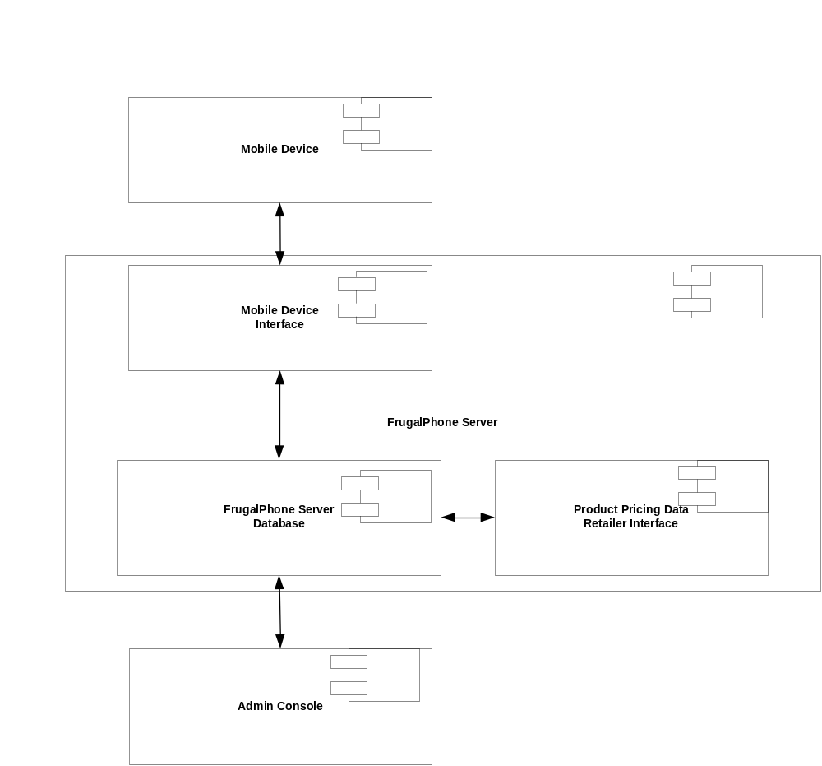
Figure 1 - FrugalPhone Component Diagram

Mobile Device
The Mobile Device component of the system is the software application that is running on the consumer’s Mobile Device. This component has the responsibility of sending data to and receiving data from the Mobile Device Interface as well as allowing the consumer to enter product input data and view pricing result data.

Mobile Device Interface
The Mobile Device Interface is a component within the FrugalPhone Server. The responsibilities of the Mobile Device Interface include receiving product input data from the Mobile Device, performing queries against the FrugalPhone server database with that information, and formatting and returning the pricing result data.

FrugalPhone Server Database
The FrugalPhone Server Database is the component of the system that stores information needed for the application and provides utilities for accessing and manipulating that data.

Product Pricing Data Retailer Interface

The Product Pricing Data Retailer Interface is the component of the system that allows retailers to provide product pricing data feeds to the FrugalPhone system. A list of URLs for properly formatted data feed files is stored as the Product Pricing Data Location(s) FrugalPhone Server Management Parameter. These URLs are entered into the FrugalPhone Server Database by a system administrator via the Admin Console.
The Product Pricing Data Retailer Interface will refresh at a rate defined by the Product Pricing Data Refresh Rate, another FrugalPhone Server Management Parameter.

Admin Console
The Admin Console is the component of the system that allows a system administrator to view the status of the FrugalPhone server, change the FrugalPhone Server Management Parameters, and manage system administrator accounts. This system component is implemented as a JSP-based web application.

Integration Tests
This section details the black box tests needed to ensure that each component of FrugalPhone is interacting with other components as expected. These tests are extremely important in the context of FrugalPhone because of its multi-threaded, cross-platform nature.

Mobile Device – Mobile Device Interface

Successful Comm Message
Purpose | The purpose of this test is to ensure that the cross-device communication between the mobile device and the mobile device interface is functional.
External Dependencies | Ensure that the Mobile Device has wireless connectivity.
Test Description | 1) Start the FrugalPhone client application  2) Select the UPC Entry Type  3) Input a random 12-digit UPC  4) Send the UPC code
Expected Results | As long as wireless connectivity exists, the mobile device displays information regarding the product or a screen that explains that no products have been found that match the specified UPC code.

Mobile Device Interface – FrugalPhone Server Database

Invalid Product Input Data Result
Purpose | The purpose of this test is to ensure that the Mobile Device Interface can handle invalid Product Input Data.
External Dependencies | None
Test Description | 1) Start the FrugalPhone client application  2) Select the Product Name Entry Type  3) Input and send one asterisk (*) character
Expected Results | The Mobile Device displays a message that says that no products matched the search criteria.

Zero-Result Database Query
Purpose | The purpose of this test is to ensure that the Mobile Device Interface can handle the case where no products match the Product Input Data.
External Dependencies | Find a UPC code that does not appear in the database.
Test Description | 1) Start the FrugalPhone client application  2) Select the UPC Entry Type  3) Input and send the UPC code that is not in the database
Expected Results | The Mobile Device displays a message that says that no products matched the search criteria.

Single-Result Database Query
Purpose | The purpose of this test is to ensure that the Mobile Device Interface can handle the case where only one product matches the Product Input Data.
External Dependencies | Find the UPC code of a product in the database that only has one entry in the database.
Test Description | 1) Start the FrugalPhone client application  2) Select the UPC Entry Type  3) Input and send a UPC code of a product with only one entry in the database
Expected Results | The Mobile Device displays the single result.

Multiple-Result Database Query
Purpose | The purpose of this test is to ensure that the Mobile Device Interface can handle the case where multiple products match the Product Input Data.
External Dependencies | Find the name of a product in the database that has multiple entries in the database.
Test Description | 1) Start the FrugalPhone client application  2) Select the Product Name Entry Type  3) Input and send a product name of a product with many entries in the database
Expected Results | The Mobile Device displays multiple results.

Product Pricing Data Retailer Interface – FrugalPhone Server Database

Unsuccessful Product Pricing Data Upload
Purpose | The purpose of this test is to ensure that the Product Pricing Data Retailer Interface can handle incorrectly formatted Product Pricing Data.
External Dependencies | None
Test Description | 1) Make a Product Pricing Data Location with incorrectly formatted Product Pricing Data  2) Add the Product Pricing Data Location to the list of Product Pricing Data Locations  3) Wait for Product Pricing Data Refresh Rate
Expected Results | When the Product Pricing Data updates, a message is logged to the Admin Console saying that the Product Pricing Data Location contained incorrectly formatted Product Pricing Data.

Product Pricing Data Location Addition
Purpose | The purpose of this test is to ensure that the Product Pricing Data Retailer Interface can handle new Product Pricing Data Locations.
External Dependencies | Create one (1) properly formatted Product Pricing Data Location with non-duplicate Product Pricing Data.
Test Description | 1) Conduct the Add Feed File Location test (3.4.7)  2) Start the FrugalPhone client application  3) Select the UPC Entry Type  4) Input and send the UPC code corresponding to a Product Pricing Data
Expected Results | 1) The Add Feed File Location test (3.4.7) performs as expected.  2) The Mobile Device displays a result including the one in the Product Pricing Data Location.

Product Pricing Data Addition
Purpose | The purpose of this test is to ensure that the Product Pricing Data Retailer Interface can handle new Product Pricing Data.
External Dependencies | Find an existing (modifiable) Product Pricing Data Location that has been uploaded.
Test Description | 1) Add a new, non-duplicate Product Pricing Data to the existing Product Pricing Data Location  2) Wait for Product Pricing Data Refresh Rate  3) Start the FrugalPhone client application  4) Select the UPC Entry Type  5) Input and send the UPC code corresponding to the added Product Pricing Data
Expected Results | The Mobile Device displays a result including the one in the Product Pricing Data.

Duplicate Product Pricing Data
Purpose | The purpose of this test is to ensure that the Product Pricing Data Retailer Interface can handle duplicate Product Pricing Data.
External Dependencies | Find an existing (modifiable) Product Pricing Data Location that has been uploaded.
Test Description | 1) Add a new, duplicate Product Pricing Data to the existing Product Pricing Data Location  2) Wait for Product Pricing Data Refresh Rate  3) Start the FrugalPhone client application  4) Select the UPC Entry Type  5) Input and send the UPC code corresponding to the added Product Pricing Data
Expected Results | The Mobile Device displays a result including the one in the Product Pricing Data, but the duplicate entry is only shown once.

Modified Product Pricing Data Entry
Purpose | The purpose of this test is to ensure that the Product Pricing Data Retailer Interface can handle modified Product Pricing Data.
External Dependencies | Find an existing (modifiable) Product Pricing Data Location that has been uploaded
Test Description | 1) Modify a Product Pricing Data in the existing Product Pricing Data Location  2) Wait for Product Pricing Data Refresh Rate  3) Start the FrugalPhone client application  4) Select the UPC Entry Type  5) Input and send the UPC code corresponding to the modified Product Pricing Data
Expected Results | The Mobile Device displays a result including the modified Product Pricing Data, with the most up-to-date product details.

Admin Console – FrugalPhone Server Database

Login Success
Purpose | The purpose of this test is to ensure that the System Administrator can login to the Admin Console.
External Dependencies | The user has a System Administrator account.
Test Description | 1) Type the username and password into the Admin Console login screen  2) Click the “Sign In” button
Expected Results | The user is directed to the AdminOptions Screen (SDS 4.5.1.3)

Incorrect Login Failure
Purpose | The purpose of this test is to ensure that incorrect username and password pairs do not allow the user to access the main features of the Admin Console.
External Dependencies | The user knows an incorrect System Administrator account username and password pair.
Test Description | 1) Type the incorrect username and password pair into the Admin Console login screen  2) Click the “Sign In” button
Expected Results | The user is directed to the LoginErrorRetry Screen (SDS 4.5.1.2)

Add System Administrator
Purpose | The purpose of this test is to ensure that System Administrator accounts can be added.
External Dependencies | None
Test Description | 1) Login to the Admin Console  2) Click “Manage System Administrators”  3) Click “Add System Administrator”  4) Enter a valid username, password, and confirmation password  5) Click the “Add System Administrator” button  6) Click the “Logout” button  7) Perform the Login Success test (3.4.1) with the username and password in step (4)
Expected Results | 1) No error message appears after step (5)  2) The same results from the Login Success test (3.4.1)

Remove System Administrator
Purpose | The purpose of this test is to ensure that System Administrator accounts can be removed.
External Dependencies | Know the username and password of an existing System Administrator account.
Test Description | 1) Login to the Admin Console  2) Click “Manage System Administrators”  3) Click “Delete System Administrator”  4) Select a System Administrator account whose username and password you know  5) Click the “Delete Selected” button  6) Click the “Logout” button  7) Perform the Incorrect Login Failure test (3.4.2) with the username and password in step (4)
Expected Results | 1) No error message appears after step (5)  2) The same results from the Incorrect Login Failure test (3.4.2)

Change System Administrator Password
Purpose | The purpose of this test is to ensure that the password of a System Administrator account can be modified.
External Dependencies | Know the username and password of a System Administrator account.
Test Description | 1) Login to the Admin Console  2) Click “Manage System Administrators”  3) Click “Change Password”  4) Enter the existing password, a valid new password, and a confirmation of the new password  5) Click the “Submit Change” button  6) Click the “Logout” button  7) Perform the Incorrect Login Failure test (3.4.2) with the username and old password  8) Perform the Login Success test (3.4.1) with the username and new password
Expected Results | 1) No error message appears after step (5)  2) The same results from the Incorrect Login Failure test (3.4.2) after step (7)  3) The same results from the Login Success test (3.4.1) after step (8)

Change Connection Timeout
Purpose | The purpose of this test is to ensure that the connection timeout server management parameter can be modified.
External Dependencies | None
Test Description | 1) Login to the Admin Console  2) Click “Manage Server Parameters”  3) Change the number in “Connection Timeout” field  4) Click the “Submit Changes” button  5) Click “View Server Status”  6) Click “Manage Server Parameters”
Expected Results | 1) No error message appears after step (4)  2) The number in the “Connection Timeout” field matches the number input in step (3)

Add Feed File Location
Purpose | The purpose of this test is to ensure that the connection timeout server management parameter can be modified, specifically by adding a Feed File Location.
External Dependencies | None
Test Description | 1) Login to the Admin Console  2) Click “Manage Server Parameters”  3) Add a Feed File Location  4) Click the “Submit Changes” button  5) Click “View Server Status”  6) Click “Manage Server Parameters”
Expected Results | 1) No error message appears after step (4)  2) The Feed File Location input in step (3) is in the list of Feed File Locations

Remove Feed File Location
Purpose | The purpose of this test is to ensure that the connection timeout server management parameter can be modified, specifically by removing a Feed File Location.
External Dependencies | At least one existing Feed File Location
Test Description | 1) Login to the Admin Console  2) Click “Manage Server Parameters”  3) Remove a Feed File Location  4) Click the “Submit Changes” button  5) Click “View Server Status”  6) Click “Manage Server Parameters”
Expected Results | 1) No error message appears after step (4)  2) The Feed File Location removed in step (3) is no longer in the list of Feed File Locations

Change Feed File Refresh Rate
Purpose | The purpose of this test is to ensure that the feed file refresh rate server management parameter can be modified.
External Dependencies | None
Test Description | 1) Login to the Admin Console  2) Click “Manage Server Parameters”  3) Change the number in “Feed File Refresh Rate” field  4) Click the “Submit Changes” button  5) Click “View Server Status”  6) Click “Manage Server Parameters”
Expected Results | 1) No error message appears after step (4)  2) The number in the “Feed File Refresh Rate” field matches the number input in step (3)

